PARTS-SMARTS 1969 1/2 TO 1971 CARB IDLE SOLENOIDS
Text and Photos by Frank Badalson

In this article, I will attempt to straighten out all the misinformation on carb solenoids by focussing on correct application rather than Chrysler part numbers.

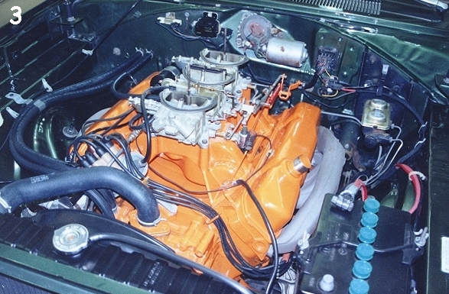
Carb idle solenoids were used on all 69 1/2, 70 (including AAR/TA) and 71 six-pack engines, 70 and 71 AVS equipped engines and 70-1 Hemi engines.
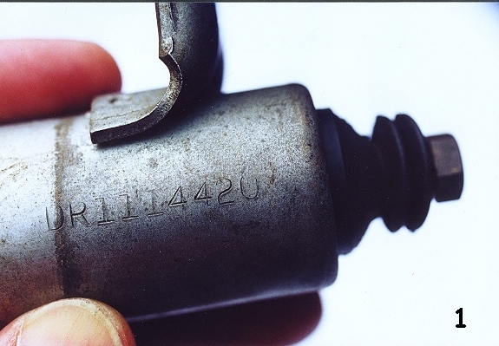
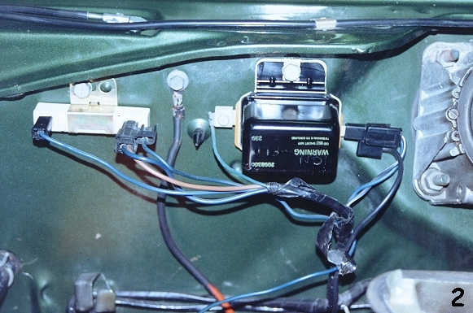
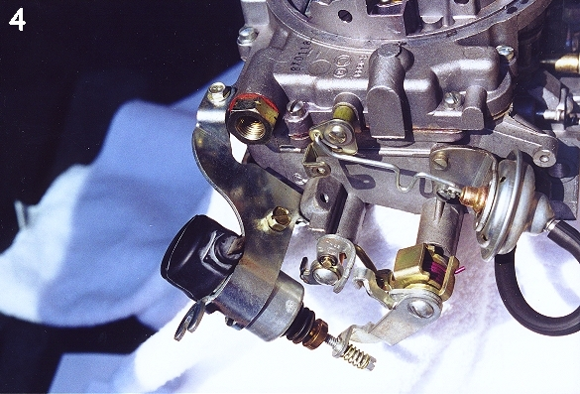
All 69 1/2 440-6 engines used the same solenoid mounted to the left side of the intake manifold. The solenoid plunger (which is adjustable) should have a brass HEX head. All solenoids are stamped with an identification number that faces the front (radiator) of the car. The 69 1/2 I.D. number is DR1114420 (see figure 1.) This is the ONLY number research has shown to be used on these cars.
The separate "hot" wire, not part of the wiring harness, is used to activate the solenoid. This wire is a special heat resistant wire, 55 inches long and very dark brown in color. One end (a unique dual plug head, figure 2) attaches to the voltage regulator and the other to the positive terminal on the bottom of the solenoid.
The wire is routed along the right side of the intake to the front of the intake then along the left side of the intake. A special nylon, adhesive backed clip is mounted to the inside of the left valve cover. The solenoid wire rests in this clip, figure 3.

In 1970 all 340-4 bbl, 340-6, 440-4bbl, 440-6 and Hemi engines utilized a carb idle solenoid. Each solenoid will be covered separately.

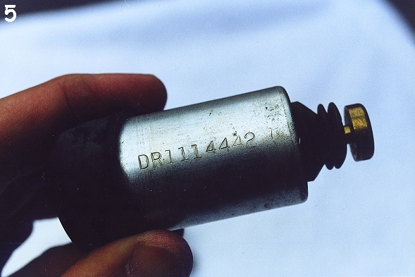
The 1970 340-4bbl engine utilized a Carter AVS carb. Attached to the right side of the carb via a special bracket was the solenoid, figure 4. The solenoid has ID numbers stamped on the barrel that are difficult to observe due to the type of bracket used. However the ID numbers found for the application are DR1114442, figure 5. The plunger (which is adjustable) should have a brass ROUND head. There is one positive (hot) wire connected to the terminal at the bottom of the solenoid.

All 340-6, AAR and T/A cars were equipped with a solenoid. The solenoid is attached to a special bracket. The bracket is mounted to the rear of the front 2-bbl. The two rear carb (to intake) bolts secure the unique bracket, figure 6. The ID number, DR1114429, figure 7, is stamped on the side of the barrel and faces the front (radiator) of the car. The plunger (adjustable) should have a brass ROUND head. The solenoid wire, medium blue in color, is incorporated in the wiring harness. The throttle return spring bracket incorporates a special nylon clip (usually white or black) that holds the wire.
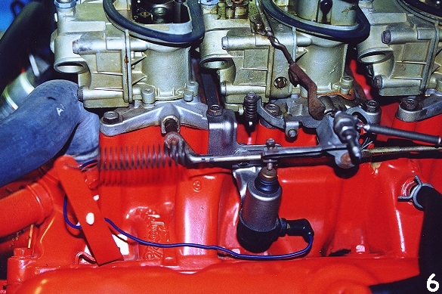
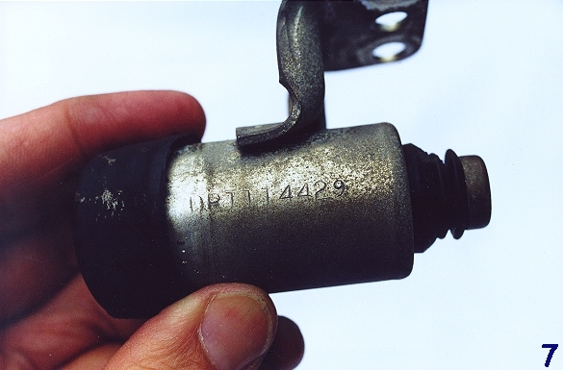
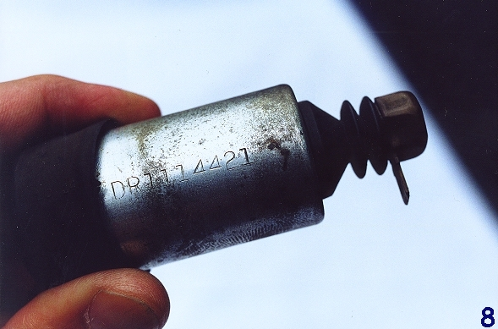
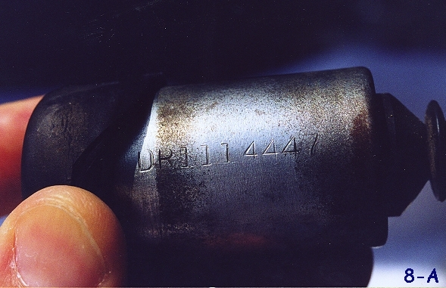
All AVS equipped 440-4bbl. engines utilized a solenoid mounted in a special bracket attached to the right side of the carb. The bracket is the same as used on the 340-4bbl. AVS, the solenoid however, is quite different. The ID numbers found for this application are (generally found on 70 cars) DR1114421 and (generally found on 71 cars) DR1114447 (figures 8 and 8A respectively) stamped into the side of the barrel. Figure 8B shows the unique configuration of this application. Notice there is a secondary ground, male terminal at the head of the solenoid plunger, figure 8C. The plunger head is a brass hex design and is adjustable. The positive wire, medium blue in color, connects to the terminal at the bottom of the solenoid.
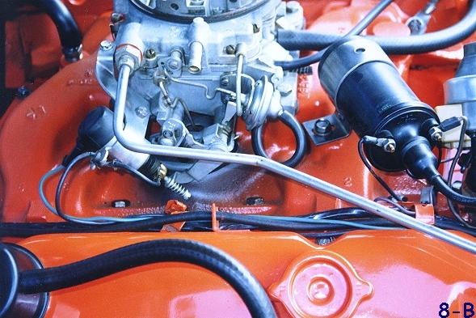
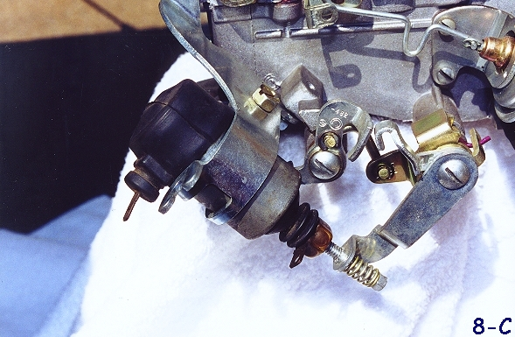

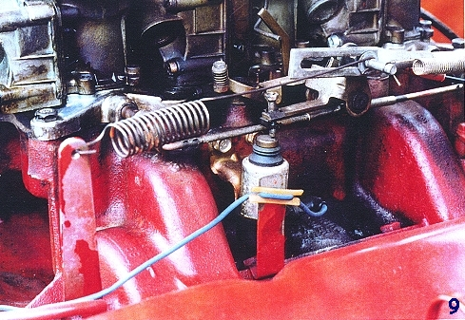
All 1970 440-6 engines used the same solenoid mounted to the left side of the intake manifold. The solenoid plunger (adjustable) should have a ROUND brass head. The ID number, DR1114429, (same as fig. 7) is stamped into the barrel of the solenoid and faces the front (radiator) of the car. The positive wire, medium blue in color, connects to the terminal at the bottom of the solenoid. The wire is a part of the wiring harness. A special bracket mounted to the second (from the front) intake manifold bolt incorporates a nylon clip that holds the solenoid positive wire, figure 9.
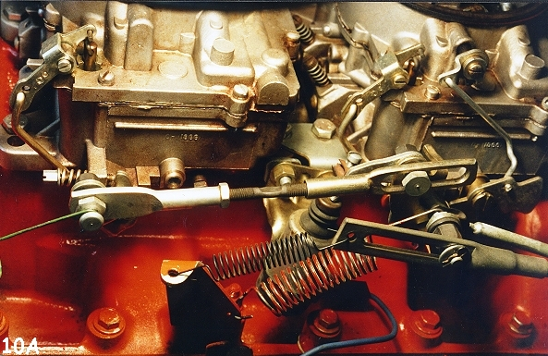
All 1970 and 71 Hemi engines were equipped with a carb idle solenoid. The solenoid is attached to a special bracket mounted between the front and rear carbs on the left side, figure 10.
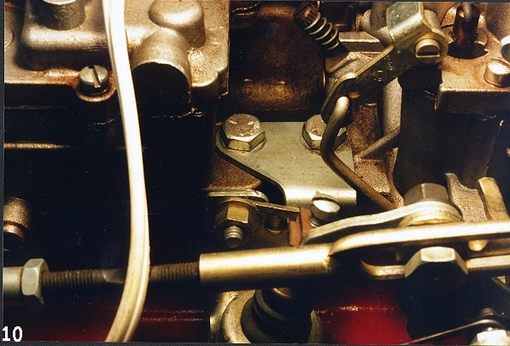
The plunger (adjustable) should have a ROUND brass head. The ID number DR1114429 (note: same as 70 440-6 and 340-6, see fig. 7) is stamped into the barrel facing the front (radiator) of the car. The positive wire, medium blue in color, connects to the terminal at the bottom of the solenoid, figure 10A. The wire is a part of the wiring harness.

The 1971 340-4bbl engines utilized a Thermo-quad carb and did not use the types of solenoids discussed here.

The 1971 440-4bbl AVS equipped engines used the same solenoid set up as the 1970 440-4bbl AVS equipped cars figures 8, 8A, 8B, and 8C.

ALL 1971 440-6 engines used the same solenoid mounted to the left side of the intake manifold, figure 11. The plunger (adjustable) should have a brass HEX head with a male ground prong, figure 11A. The positive wire, medium blue in color, connects to the terminal at the bottom of the solenoid and is incorporated in the wiring harness. The ID number, DR1114443 is stamped into the side of the barrel and faces the front (radiator), figure 11B. The positive wire is held by the same type bracket as the 70 440-6. Unique to the 71 six-pack is the upper ground wire that attaches to the male prong on the brass hex head of the solenoid. The other end of the ground wire is held in place by a special metal clip mounted under the left front 2-bbl carb bolt, see figure 11.

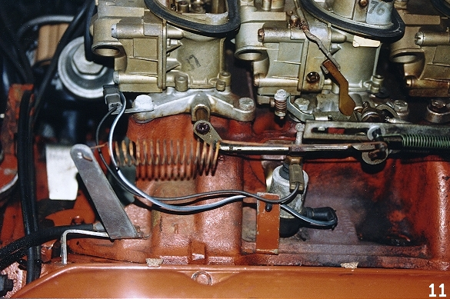
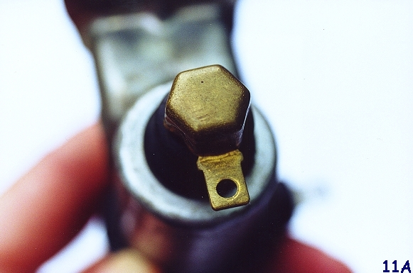
A word about fasteners, the correct bolts used to mount the 69 1/2 and 70-71 six-pack solenoids to the intake are either dark phosphate, gold/zinc dichromate or cadmium plated. They are 1/4 - 20 thread with 7/16 indented hex head with a 1/2 inch captive washer. Some of the washers were found to have securing points generally to insure a good ground. The overall length including head is approximately 5/8 inch. Various head markings have been found and some were found to be unmarked.
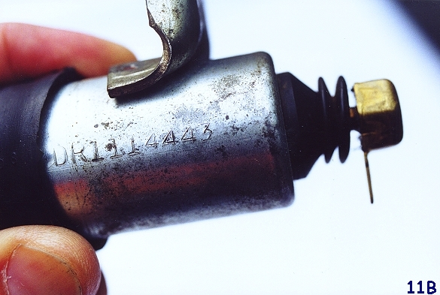
The information contained in this article is based on research conducted over many years utilizing verifiable ORIGINAL and UNRESTORED vehicles.

Ed.
Contrary to popular Mopar belief, there is not a "One Size Fits All" situation when it comes to having the proper Idle Solenoid attached to your vehicle! We are very happy to have Frank Badalson as a regular contributor to the Broadcast Sheet. Hopefully Franks many years of accumulating an enormous database on original, correct details on all aspects of muscle Mopars will help you make an informed choice on the purchasing of correct parts for your vehicle. Frank, along with Roger Gibson, his partner in the manufacturing of authentic restoration parts are both committed to providing the Mopar hobby with technical assistance and parts for our treasured vehicles. Their philosophy is to take the extra time, expense and aggravation in order to produce a product superior to other so-called "correct reproductions". They have most of the small detail parts for the solenoid including - adjustment screws and clips, solenoid mounting bolts for the 440-6 solenoid; brackets, wires and hardware for all 4-bbl applications; and all wires and clips for the 69 1/2 440-6.

